Exhibitor Manual and Order Form
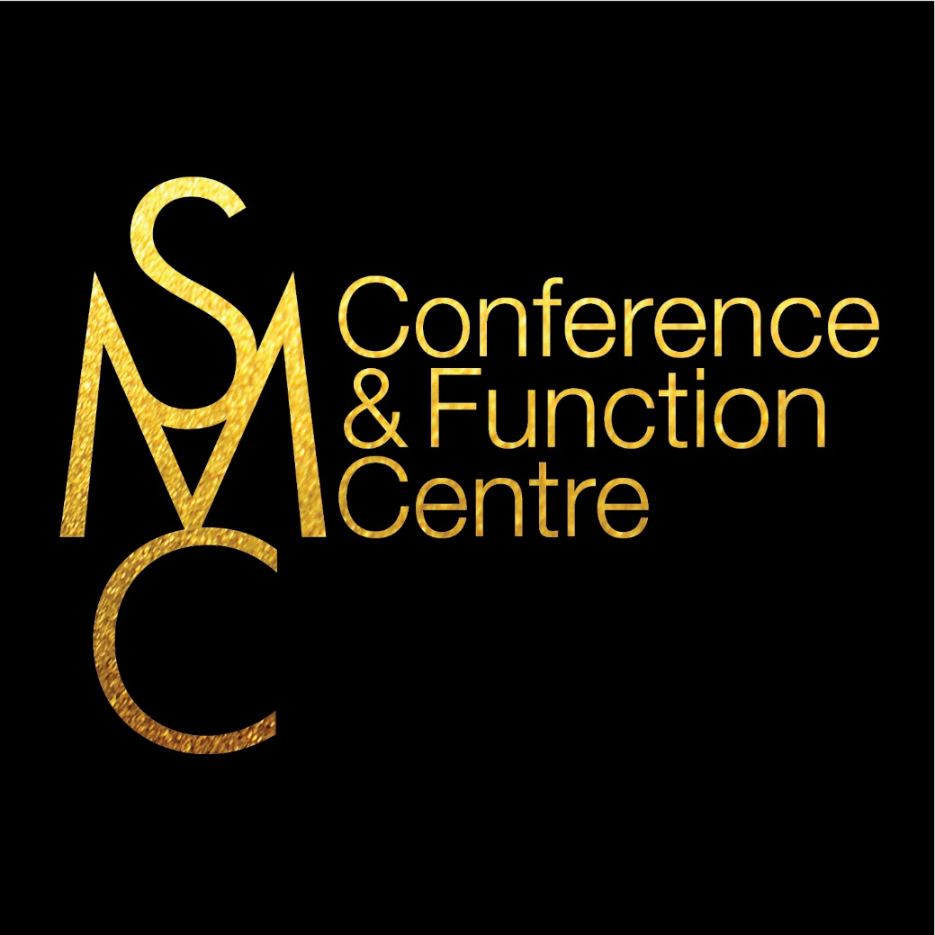
Insert Event Name

Important Dates:

Bump In: Insert correct details
Bump Out: Insert correct details
Access:
Main vehicle access to the loading dock area at the Sydney Masonic Centre is 66 Goulburn Street, Sydney. The driveway is located between SMC’s Goulburn St entrance and the Civic Hotel.

The loading dock at the Sydney Masonic Centre is for loading and unloading only. It is open Monday to Friday from 0700 – 1700.

Please note there is a 2.9m height restriction and there is no pallet jack or fork lift on site.

If you have larger items to be delivered using the loading dock please contact SMC for more information.

If you are personally delivering your materials, please use The Upper Basement Loading on 66
Goulburn Street (driveway between SMC and the Civic Hotel).

The SMC does have a goods lift available to assist with the bump in and out process. Please see below for the specific dimensions of the lift:

Heavy goods lift door: Height: 200 cm | Width: 160 cm
Heavy goods lift car: Height: 270 cm | Width: 230 cm | Depth: 170 cm
Max load 1814 kg

The Sydney Masonic Centre will not take delivery of any goods on behalf of exhibitors without the appropriate label. All deliveries must come with adequate manpower or equipment to unload. If delivery boxes are over 20kgs please contact SMC to discuss delivery options

Parking:
SMC and Secure Parking have teamed up to offer you 15% off ALL parking products at the Secure World Square Carpark – 50 Goulburn Street - when booking online:

https://www.secureparking.com.au/en-au/car-parks/australia/new-south-wales/sydney/sydney-cbd/world-square-car-park

Click “BOOK NOW” next to any of the products, make that booking and apply the promotional code: SMCFC16
Deliveries:
All Deliveries must be labelled with the completed Delivery Form (last page of this document).
All deliveries must come with adequate manpower or equipment to unload. If delivery boxes are over 20kgs please contact SMC to discuss delivery options.

Arrangements should be made for goods to arrive no earlier than 3 days prior to the event (Insert date). Venue staff will deliver all exhibitor goods correctly labelled to the corresponding stand number/name in time for bump in.
Please ensure that you make arrangements in advance for couriers to pick up exhibitor goods at the end of the exhibition. It is the exhibitor’s responsibility to pack, seal, label and arrange shipment for goods at the conclusion of the event. All goods must be packed and labelled with consignment notes and delivery address ready for pick up no later than 3 days post event (Insert date)

All consigned packages can be left at your table and a staff member from SMC will take them from the table to the loading dock. Please be aware any goods not packed securely or without a
consignment note may be considered rubbish.

Security:
During set up and take down times and exhibition opening times, the area will be open and SMC suggest that exhibitors take care of their goods. Please do not leave any valuable items on your table. Whilst every precaution is taken, the Sydney Masonic Centre cannot accept any
responsibility for loss or damage, which may occur to persons or property at the exhibition from any cause whatsoever.

Stand Catering:

No exhibitor or person shall distribute or give away any item of food, drink or tobacco, not
supplied by the Sydney Masonic Centre, to members of the public or trade exhibition visitors
without the express written consent of the Sydney Masonic Centre.

The Sydney Masonic Centre reserves the right to remove any food and beverage not authorised
by the Sydney Masonic Centre.

Insurance:

It is recommended that exhibitors have Public Liability Insurance for the period of the exhibition.

Cleaning:

Exhibition areas will be cleaned nightly and this is included in the cost of participation. Please place all rubbish in the aisles at the end of each day, after the exhibition has closed. For security reasons rubbish left on any stand will not be removed. Please ensure no item is affixed to the venue doors, glass, floors etc. Any infractions will create a removal, cleaning and/or resurfacing cost charged to the exhibitor.

If you have any specific waste requirements, especially toxic, grease, oil etc. please contact SMC to discuss correct disposal methods

Contacts Details:

Conference Secretariat:
Client to complete

Venue Contact:
SMC to complete

SMC Connectivity
Simply choose the superior solution that best suits your needs

Connection Type | Costs
SMC Free Wi-Fi | Free
Wired Connection | $50 per connection per day
Premium Wireless  500 mbps up and down | $249 per network

For best results we recommend the use of 5GHz wireless compatible devices.
Older 2.4 GHz devices are supported but results can vary in line with the limitations of the device.

SMC Free Wi-Fi
This complimentary service is shared by all visitors to SMC. It is not designed to provide a guaranteed number of concurrent users in a particular location, however is more than suitable for basic internet browsing, email and social media.
Wired Connection
A Wired Connection allows you to be directly connected to our network and is the perfect solution if your event requires video live streaming, webcasting or video conferencing, for example. As the option with the greatest security, Wired Connection is ideal if you are looking for secure and steady access for long periods of time.
Premium Wireless
With SMC’s Premium Wireless option, you will be given your own login and password for private access to the wireless network. With upload and download speeds of up to 500 mpbs, Premium Wireless is best suited to events requiring all attendees to be connected and events utilising multiple spaces, or for file sharing, VPNs and online workshops. Premium Wireless download speeds vary depending on the number of users at any one time and can be packaged with other services to suit your needs

DELIVER TO | SMC Conference & Function Centre  SMC, Upper Basement Loading Dock  66 Goulburn St, NSW 2000  Accepted between 7 am and 5 pm, Monday to Friday  Driveway located between SMC Goulburn St doors and Civic Hotel  2.9m height restriction. No pallet jack or fork lifts on site.
CONTACT NAME:
(Person Responsible for Delivery)
CONTACT PHONE NUMBER:
(Person Responsible for Delivery)
EVENT NAME:
EVENT DATES:
BOOTH NAME:
BOOTH NUMBER:
TOTAL NUMBER OF ITEMS/BOXES:
ITEM/BOX NUMBER:

Loading Dock Access
The address is Upper Basement Loading Dock, 66 Goulburn St, Sydney NSW 2000.

Access is permitted Monday to Friday, between 7 am and until 5 pm. Please follow the directions of the Loading Dock attendant.

The driveway is located between SMC’s Goulburn St entrance and the Civic Hotel – see image below.

Please note there is a 2.9 meter height restriction and there is no pallet jack or fork lift on site.

Vehicles above 2.9 meters should consider loading and unloading from Goulburn or Castlereagh Streets either early in the morning or late at night. Please contact your event manager to arrange a quote for this out-of-hours access to ensure the venue is open. Any parking fines are the responsibility of the driver.

Heavy Goods Lift Dimensions:
Heavy goods lift door: Height: 200 cm | Width: 160 cm
Heavy goods lift car: Height: 270 cm | Width: 230 cm | Depth: 170 cm
Max load 1814 kg

